FTP Server Configuration

Step 1:

Install the package ftp Package

$ apt install vsftpd

Step 2:

Create the new group and add new user to the ftpgroup

$ groupadd ftpgroup

$ cat /etc/group

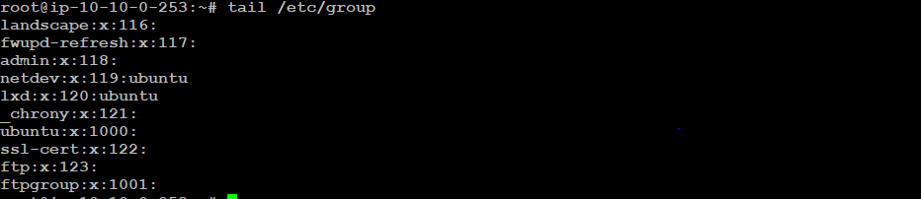

$ adduser dhana --shell /sbin/nologin

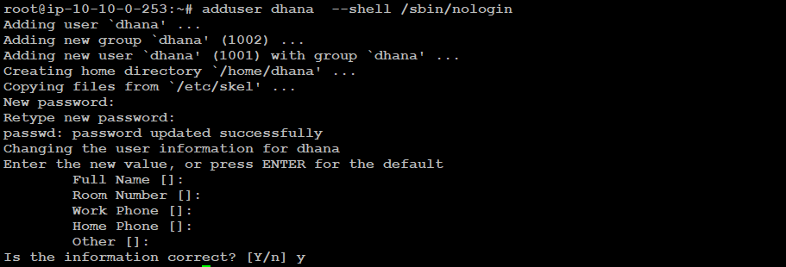

$ usermod -aG ftpgroup dhana

$ cat /etc/group



Note:

Check in the /etc/shells "/sbin/nologin" is present or not. If not means add in the file /sbin/nologin

$ cat /etc/shells

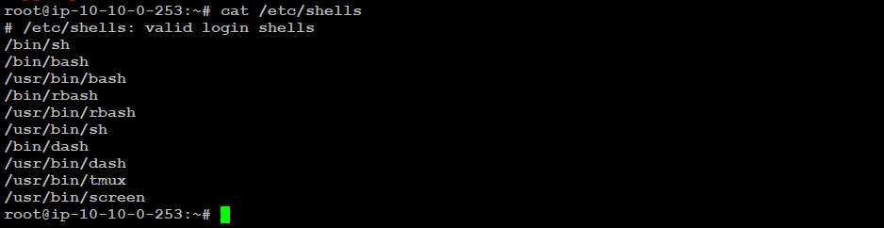

$ vim /etc/shells

# /etc/shells: valid login shells

/bin/sh

/bin/bash

/usr/bin/bash

/bin/rbash

/usr/bin/rbash

/usr/bin/sh

/bin/dash

/usr/bin/dash

/usr/bin/tmux

/usr/bin/screen

/sbin/nologin

:wq

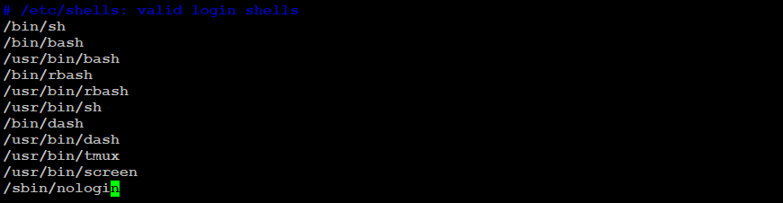

$ cat /etc/shells

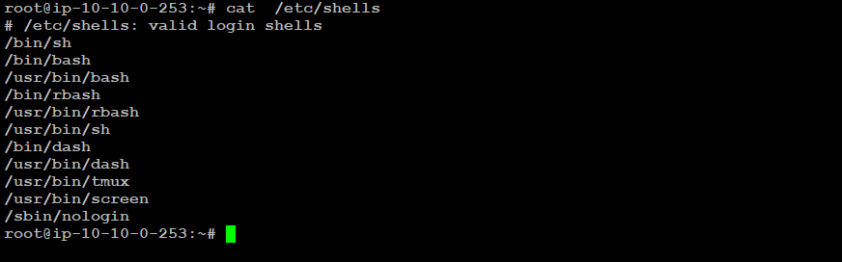

Step 3:

Add changes in configuration file

$ cp /etc/vsftpd.conf /opt/vsftpd.conf_backup



Note:

Take backup configuration file for safe

##now add the changes in configuration

$ vim /etc/vsftpd.conf

# files.

22 listen_ipv6=YES

23 #

24 # Allow anonymous FTP? (Disabled by default).

25 anonymous_enable=NO

26 #

27 # Uncomment this to allow local users to log in.

28 local_enable=YES

29 #

30 # Uncomment this to enable any form of FTP write command.

31 write_enable=YES

# ASCII mangling is a horrible feature of the protocol.

56 # Activate logging of uploads/downloads.

57 xferlog_enable=YES

99 ascii_upload_enable=YES

100 ascii_download_enable=YES

101 #

102 # You may fully customise the login banner string:

103 ftpd_banner=Welcome to FTP service.

121# chroot)

122 chroot_local_user=YES

123 #chroot_list_enable=YES

156 #add new lines by dhana

157 userlist_enable=YES

158 userlist_deny=NO

159 userlist_file=/etc/list_user_ftp

160 local_root=/var/www/html/xdocs/

161 allow_writeable_chroot=YES

162 ##passive enable

163 pasv_enable=YES

164 pasv_min_port=1024

165 pasv_max_port=1048

166 pasv_address=65.0.103.142 # #ip address if it's cloud means add public ip address or it on-prem means you can private IP.

:wq

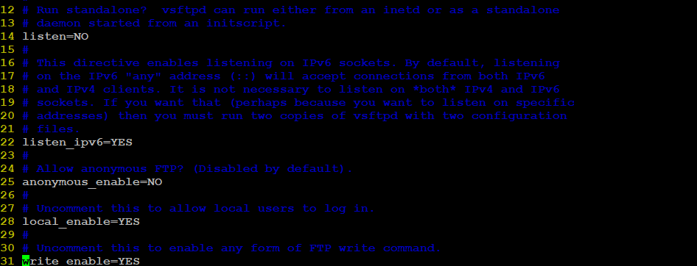

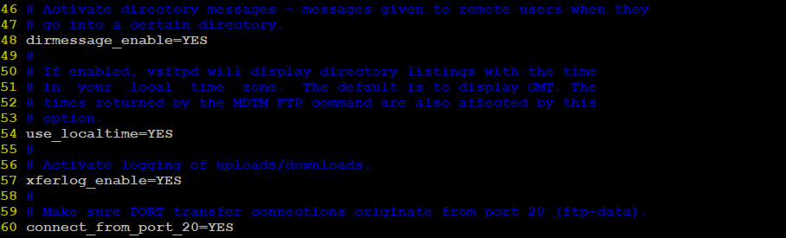

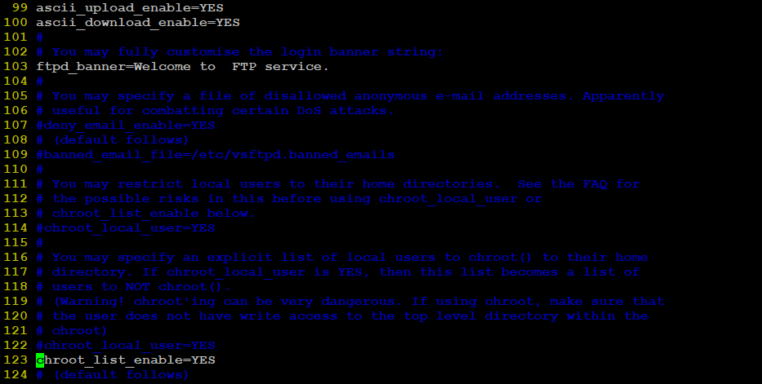

Step 4:

Create file to add user to access ftp shared file

$ vim /etc/list_user_ftp

dhana

:wq

Step 5:

Restart the service

$ systemctl restart vsftpd.service

$ systemctl status vsftpd.service

Step 6:

Apply owner permission and file permission on ftp sharing file

#$ mkdir /var/www/html/xdocs

Note:

Folder not create means created folder according we mentioned in configuration

$ chown -R root:ftpgroup /var/www/html/xdocs

$ chmod 770 /var/www/html/xdocs

Step7:

Open Filezile

After FileZilla installed,-> open Site Manager- > New Site. Configure the new site with following details. And fill Host field with your FTP IP Address.

Step8:

Enable the ssl certifcate for secure

$ vim /etc/vsftpd.conf

##enable ssl

##ssl enable

ssl_enable=YES

allow_anon_ssl=NO

force_local_data_ssl=YES

force_local_logins_ssl=YES

ssl_tlsv1=YES

ssl_sslv2=NO

ssl_sslv3=NO

rsa_cert_file=/etc/ssl/certs/ftp-selfsigned.crt

rsa_private_key_file=/etc/ssl/private/ftp-selfsigned.key

ssl_ciphers=HIGH

:wq

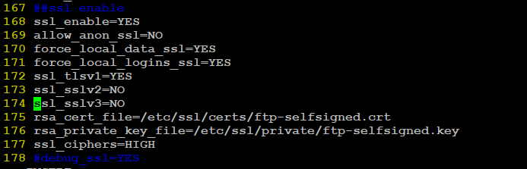

$ systemctl restart vsftpd.service

$ systemctl status vsftpd.service